# Deploying Static Website on AWS

# Website Files

* **S3 bucket is created**

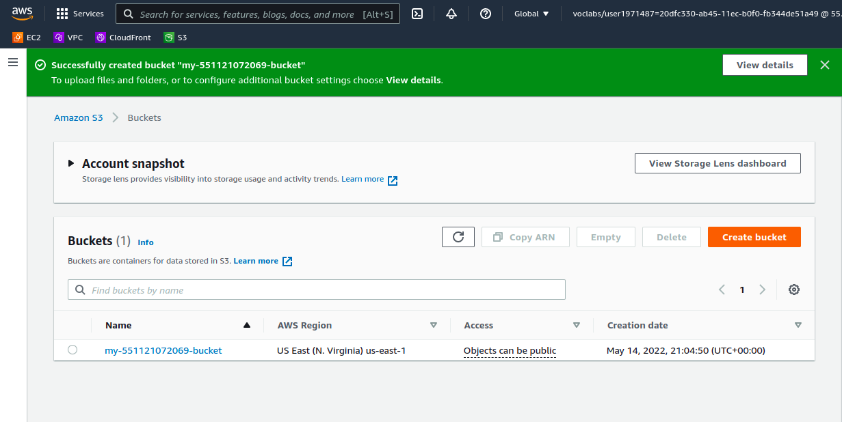

* **All website files and folders was added to the S3 bucket.**

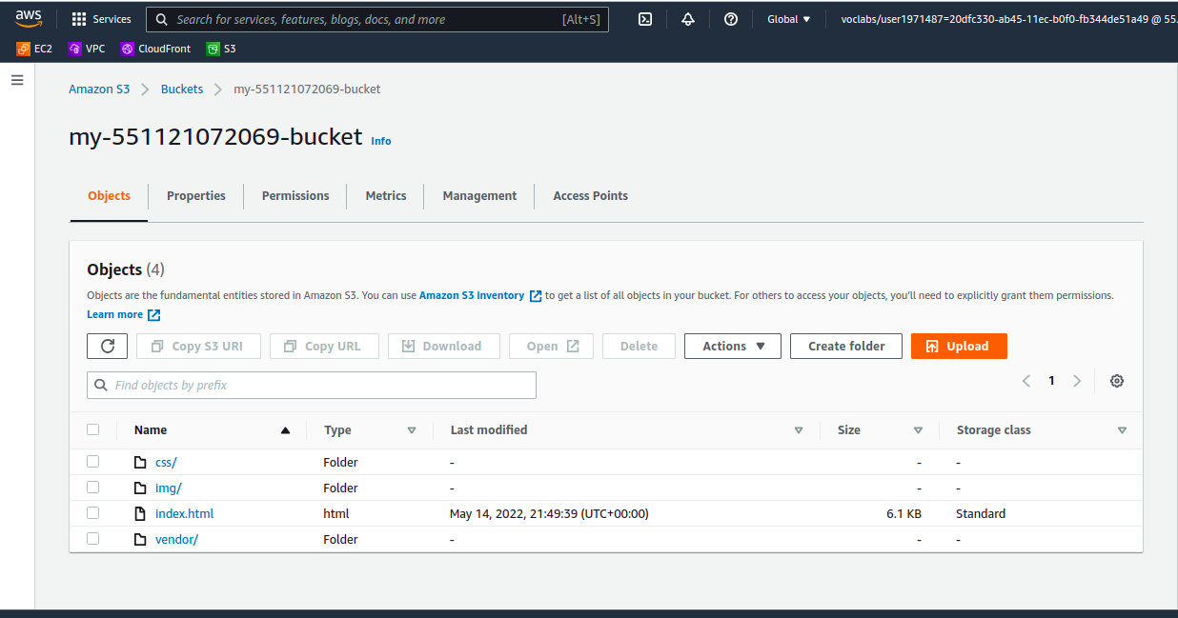

* **The S3 bucket is configured to support static website hosting.**

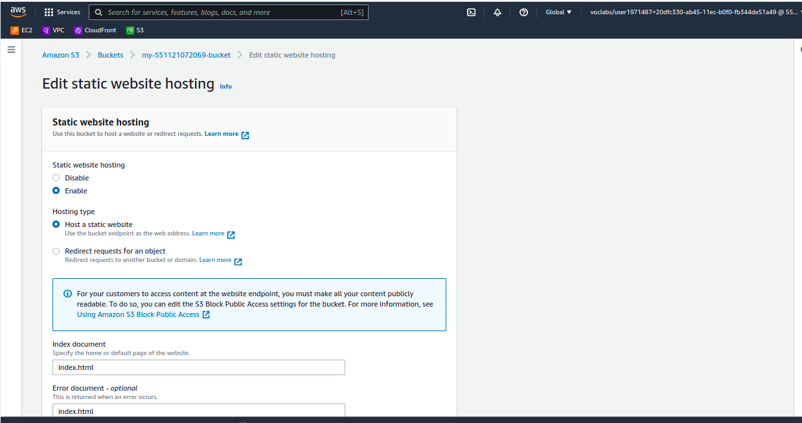

* **The S3 bucket has an IAM bucket policy that makes the bucket contents publicly accessible**

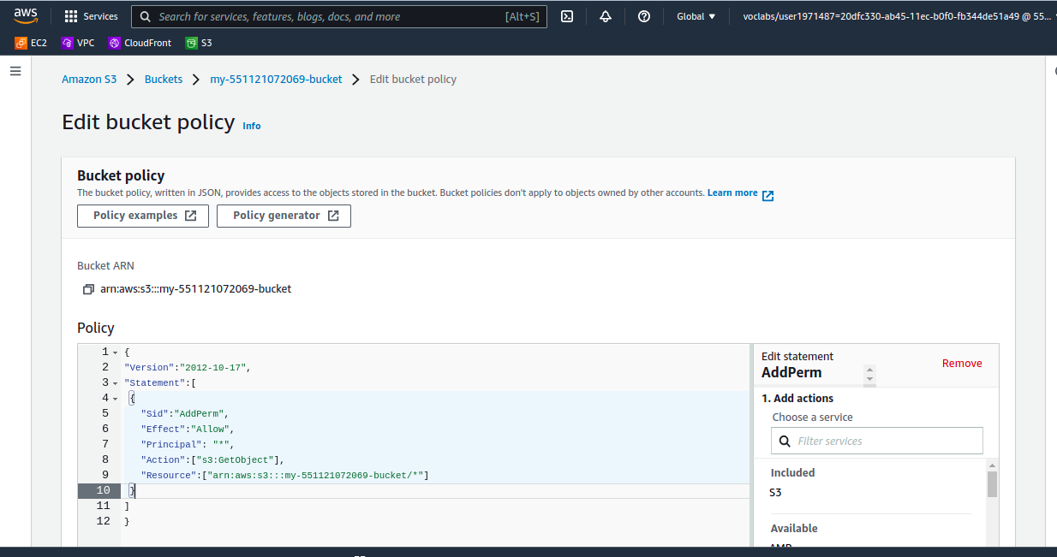

## Website Distribution

* **CloudFront has been configured to retrieve and distribute website files.**

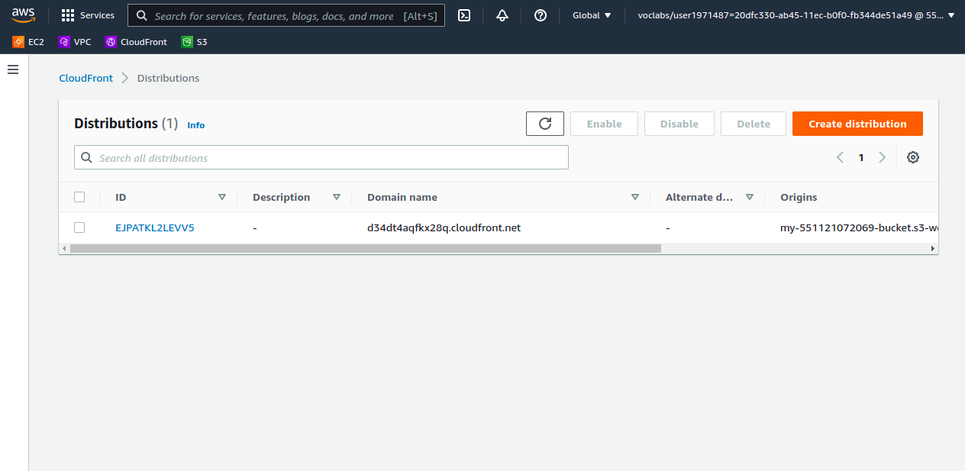

**Web Browser Access**

The website is available publicly on the following urls:

**S3**: http://my-551121072069-bucket.s3-website-us-east-1.amazonaws.com

**CloudFront**: d34dt4aqfkx28q.cloudfront.net